How do we unlock procurement information?
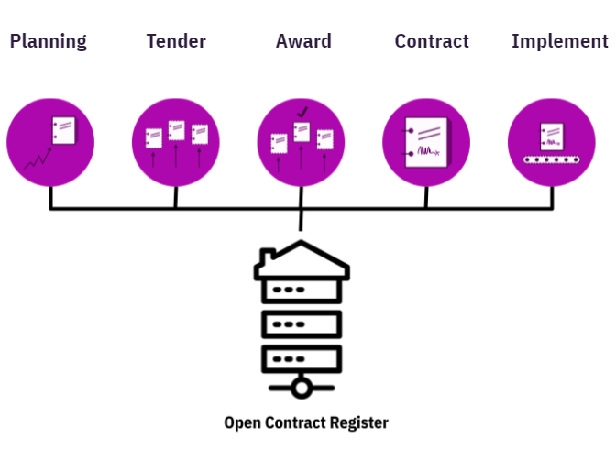
An inventory of the needs of users and re-users

May 2021

Summary
In the Netherlands, governmental authorities spend €73 billion annually in public procurement; €10 billion of which the national government spends via category management. Products, services and goods, such as occupational clothing and computers, are procured through tenders. At these volumes, procurement acts as a powerful tool for achieving social objectives. Nevertheless, abuses like corruption commonly occur. While procurement is at the very heart of public spending, there is often insufficient information on how, for whom and on what exactly this money is spent.

Open procurement means publicly disclosing procurement data and information from the entire procurement process: from planning to implementation. This helps government authorities to safeguard integrity and prevent corruption. It ensures fairer and more efficient market forces as well as greater cooperation with social organisations to monitor public services. Open procurement also results in better value for money, better public services, an improved business environment and greater public trust.

Through the Open Contract Register Project, the Open State Foundation and the Ministry of the Interior are working for the aforementioned reasons to make all government procurement data public. This report presents the results of the first phase of the project: research into the users and re-users of procurement data. According to this research, users and re-users currently have limited access to procurement data, contract and implementation data are not being published and the data that is available is not of sufficient quality. If the Open Contract Register publishes data from all the procurement phases in a timely, complete, and user-friendly manner and according to open data principles, all users and re-users can contribute constructively and critically to the efficiency and integrity of governmental procurement.

The advice for developing the Open Contract Register is to:
- Facilitate all forms of use and re-use
- Publish data from the entire tender cycle.
- Prioritise the publication of contract data
- Create a single source of truth
- Open, unless
- Apply the Open Contracting Data Standard (OCDS)
- Develop mechanisms for consultation and independent monitoring

Introduction

The necessity for open procurement
Collectively, governmental authorities in the Netherlands spend €73 billion per year on public procurement. These public resources are deployed to develop and maintain public infrastructure, such as roads and railways, and to purchase medical supplies like face masks and vaccines. The national government spends €10 billion of these resources for, inter alia, office supplies, occupational clothing, computers and catering. As such, procurement is one of the government’s most economically significant activities, as well as being a powerful tool for achieving social objectives like sustainability, security and fair working conditions. At the same time, abuses do occur regularly within this category of public expenditure. This was evidenced by, among other things, an investigation by Follow the Money — a Dutch journalistic platform — into health-care contracts and the procurement of face masks. According to KPMG, ten of the twenty-two procurement categories involve a heightened risk of abuse in the areas of human rights, labour rights and the environment.

Even though tenders form the core of public spending, with the requisite focus on efficiency and integrity, insufficient information is often provided on how, for whom and on what exactly this money is spent. According to an analysis by the Open Contracting Partnership, only 2.8% of public tenders, information and data are published globally as open data. The corona crisis has further exposed how inefficient and non-transparent tenders can lead to taxpayers not always getting good value for money. Between January and July of 2020, governmental authorities spent at least €80 billion on COVID-19-related contracts. Agencies are competing with each over the vaccines and, as yet, are unable to adequately respond to a scarce market with inexperienced suppliers. Publicly disclosing procurement data would not only address this issue, it would increase overall confidence in the process.

What is open procurement?
At its most basic level, open procurement consists of the structural and timely unlocking and public disclosure of tender and contract data, along with coordination of public and social participation and organisation of monitoring and supervision. It is essential to note that open procurement/tendering is about disclosure and participation in the entire procurement chain as well as providing information: from tender planning and the awarding of contracts to implementation and execution.

The value of open procurement
The publication of, among other things, planned tenders, the award criteria applied and the contracts awarded ensures better value for money, enhanced efficiency, more competition, higher quality services and greater integrity among the governmental authorities. For example, open contract data ensures effective supervision of public services by providing insight into who is performing the work, for what price, how these parties were selected and whether everything is being delivered on time and as agreed. This can reveal irregularities and alert governmental authorities that certain tendering processes are inefficient, uncompetitive or overly expensive. Transparent announcement and awarding of tenders also affords new, innovative companies the opportunity to participate in public tenders.

The above is supported by empirical evidence from a study the World Bank carried out in 2017. In that year, 34,000 companies in 88 countries reported that more transparent tendering processes resulted in improved competition, especially for small businesses, but also fewer bribes and kickbacks for officials. At present, many countries are reaping the benefits of publicly disclosing their procurement data. In Ukraine, the Pro-Zorro tendering platform has allowed 45% more suppliers, per contracting authority, to participate in tenders. In Paraguay, the cost of office supplies declined by €55 million due to improvements in the existing online procurement platform. The momentum for open procurement is growing. Through the Open Government Partnership, so far seventy governments have committed to opening up their public tendering, thirty-seven of which are actively working on this.

Open Contract Register Project
With the Open Contract Register Project, which is part of the fourth Open Government National Action Plan 2021-2023, the Ministry of the Interior has taken up the gauntlet to make procurement data more public. Guided by the conviction that the government and society can and must have more open relations, the Dutch government, spurred on by the Open State Foundation and other NGOs, is taking steps to open up the relationship between the government and external stakeholders.

The objective of the Open Contract Register is to build an open platform with all the public information available on government procurement for operational management. After which, the national government will actively dialogue with citizens, companies and interest groups about this information. This dialogue is expected to result in governmental procurement with greater social impact and, by extension, to an increased appreciation of the results of this use of taxpayers' money.

The envisaged project results will provide an indication of the needs of those who use or re-use governmental procurement information. A public platform where these same needs are translated into meaningful and easily accessible procurement information, and that offers possibilities for discussing this information with each other. The scope of the project is category management. Category management provides a basis for working from a singular national perspective, and this approach goes beyond merely bundling procurement and reducing costs. The category management approach will also ensure that the national government can realise its policy objectives through the procurement process. Among other things, procurement can contribute to a more sustainable, social and innovative Netherlands (‘Procuring with Impact’). For the national government, category management means that ministries will not procure products and services for themselves, but rather for each other, per product group (or category).

The Open Contract Register project will encompass three phases:
- An inventory of the information needs of the users and re-users of procurement data;
- The development and implementation of a platform for public information on governmental procurement;
- Communication, dialogue around and use or re-use of the governmental procurement information.

User research
To ascertain how the supply of public procurement information can be improved, it is vital that we better understand the specific needs of those who use or re-use the data. This chapter briefly describes the underlying approach to the inventory: user research.

User identification
To gain the fullest possible impression of the assorted data and information needs, it is important to identify the broadest possible group of users and re-users. Relevant users were identified using stakeholder mapping exercises. These include industry associations, companies, scientists, (investigative) journalists, interest groups and initiators of open procurement initiatives abroad:

Science and knowledge: Utrecht University, Tilburg University, PIANOo
Investigative journalism: Follow The Money, SOMO, independent journalists
Company & Trade Associations: MVO Nederland, Nevi, Cedris, Significant, Interface
Open Contracting Initiatives: Spend Network, ePaństwo Foundation

Desk research determined which individuals, per user type, were chosen to be interviewed. Twenty-three people in total were interviewed, some of whom were from the same organisation. In this initial phase, the main focus will be on external users and re-users. The national government’s Chief Procurement Officer (CPO) has mapped out the internal users and category managers’ wishes for the platform. These needs will be addressed as soon as an initial blueprint for the platform has been drafted that is capable of bringing together the wishes of the external and internal stakeholders, so as to encourage an optimal dialogue between the two.

Interviews and validation sessions
User research is an effective method for understanding the actual obstacles and barriers encountered by those using and re-using the procurement data. This is specific to this project. The results of the research were the impetus for developing a public platform that contains all relevant information on governmental procurement. The re-use of which largely depends on how successfully the external users and re-users’ wishes and requirements are taken into account. This type of research also prevents the research team’s assumptions from determining the focus of the research, and thereby influencing the results.

Despite the time investment involved, we decided to conduct semi-structured interviews. This type of research also offers the ability to specifically address the experiences and perspectives of the different types of users while maintaining the central focus of the project. To ensure that the results of the interviews, conducted between January to April 2021, were properly interpreted, two (public) sessions were organised on 25 and 30 March 2021 that focused on validating and refining the interim results.

Determining a focus
Similar user research has also been conducted in many other countries, And this research was also the foundation for the development of a new platform for procurement data. The focus of the central themes and the questions for the users were partially determined on the basis of this research. The interviews focused on the research and the individual use cases. How do the users work towards their intended goal? What are the necessary participation, publication, data and information requirements to be able to work effectively? And what have the results of these requirements been? Gathering this information generated valuable insights into what the central priorities and concerns should be in the design of the Open Contract Register. A register that meets the needs of the widest possible group of those who use and re-use the procurement data.

Results and analysis
This chapter provides insight into the results of the user research, more specifically, from the interviews with the users and re-users. The requirements identified provide answers to several questions for each category:
- Current issues: what are the most common issues currently experienced by users and re-users?
- Platform focus: what should the primary objectives of the Open Contract Register be?
- Information and data requirements: what are the missing information and data/data fields that are essential to successfully use and re-use the procurement data?
- Publication requirements: what are the users and re-users’ needs regarding the publication and accessibility of procurement data?
- Participation requirements: what role can the Open Contract Register play in the users and re-users’ participation in public tenders?

Current issues
The graph below illustrates the issues that users and re-users are currently experiencing regarding public tenders and contract information. Understanding these issues will provide us with an important perspective for identifying users and re-users needs for the Open Contract Register.
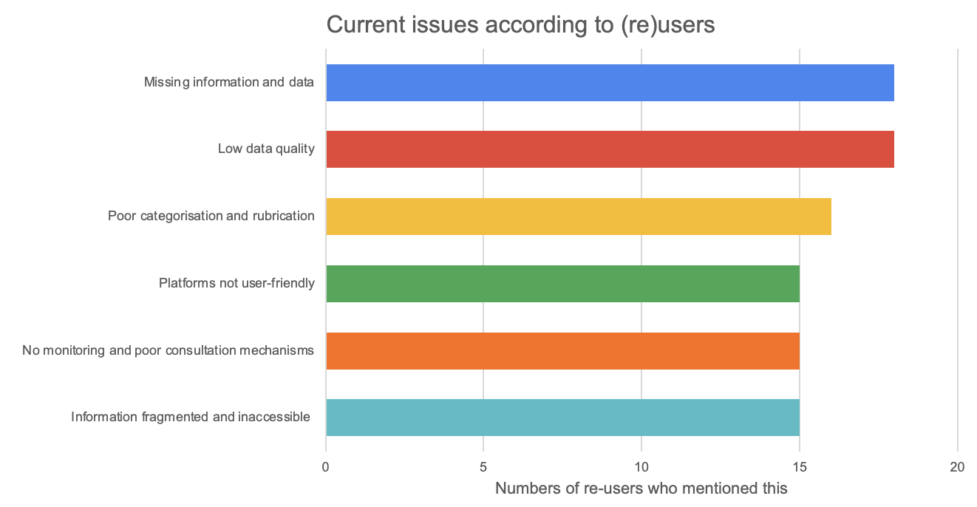

Missing information and poor data quality
All of the users and re-users interviewed indicated that crucial information and data are currently not publicly available. For example, there is currently little to no information available on the contracts entered into and the provision of public services. Government contracts are not made public. And the information that is available lacks fundamental data, such as pricing, milestones and delivery agreements. This does not mean that the information does not exist. However, only contracting authorities and specific suppliers can access the contract management portals. Users and re-users further indicated that there is only insight into the application of exclusion, award or performance criteria in very few cases. Selective information on government contracts is published on a quarterly basis. In the users and re-users’ experience, when information and data are available, the data is of poor quality. In many instances, tenders that do have information available are published without the starting and closing dates, reference numbers, keywords, CPV codes, contract categories, estimated or final contract values and the reserved contracts.

Not user friendly
Many users and re-users also indicate that how the information and data are presented impedes effective and efficient utilisation. The aggregated information on government contracts is published as PDF files, thus rendering the file data difficult to re-use. One investigative journalist indicated that publications about national government operational management use ranges to roughly indicate how much certain companies have earned on governmental contracts. For example, according to the ranges published, Comparex received between €430 and €940 million from the ministries over four years. Given that the difference between the minimum and maximum values amounts to half a billion euros, this information is not useful.
Moreover, companies, industry associations, scientists and journalists indicated that the search and filter functions for locating specific tenders within TenderNed and Negometrix and the notifications for staying informed on the publication of tenders are either not working or are overly complex. Consequently, a company may learn about a potential contract too late.

Inexistent or inadequate monitoring and consultation mechanisms
According to the interviews, in addition to the information required to monitor the efficiency and integrity of public tenders, the mechanisms for doing so are also lacking. Assorted researchers and interest groups pointed out that there are no opportunities to mark tenders in case, for example, a particular tender is showing signs that it does not satisfy the integrity criteria. An example being if there is an unreasonably short period to submit an offer.
Based on the interview, the relevant users and re-users are not given an opportunity to participate effectively in consultations. Companies, industry associations and scientists are keen to contribute to activities like developing category plans or specifying ambitious but realistic tender criteria for a specific project. Based on the interviews, there appears to be little to no possibility to do this within an online environment or platform.

Purpose of the platform
The table below illustrates what the users and re-users interviewed consider to be the main purpose of the Open Contract Register.
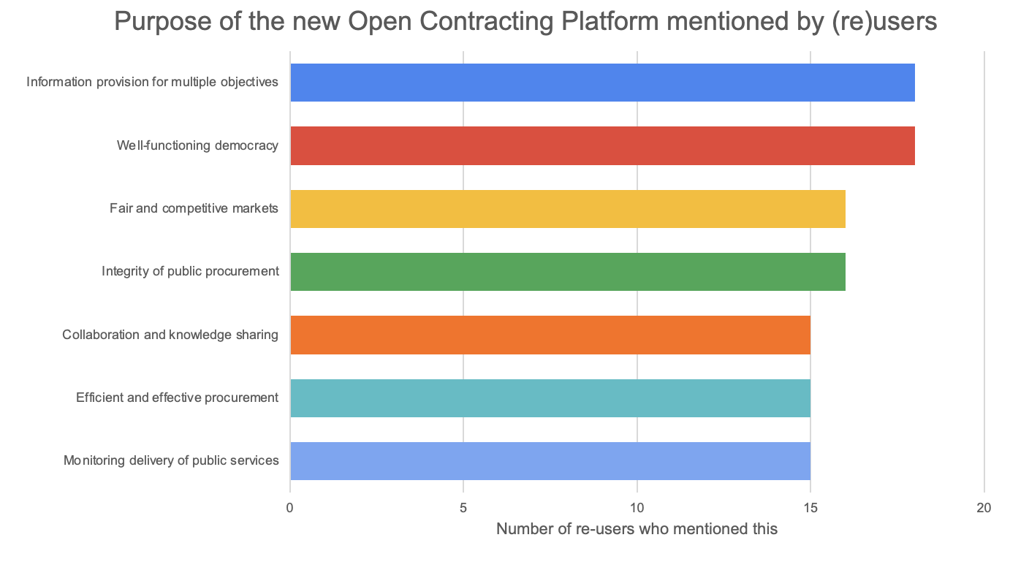

Information for multiple objectives
According to eighteen of the twenty-three users and re-users interviewed, the primary focus of the open platform should be complete information on every phase of the tendering cycle (from planning to implementation). During the interviews, various individuals stated that this new platform represents an opportunity to break away from the limited transparency of standard public tendering and contracts. Once the information is provided in a transparent manner, users and re-users can make constructive contributions. The form and content of this will vary. Four of these potential applications are examined in greater detail below.

Effective tendering
The majority of interviews pointed to the fact that an open platform, where all information and data on governmental procurement via category management has to be publicly disclosed, could play a vital role in effective tendering, as formulated in the Corporate Social Responsibility Procurement National Plan ‘Commissioning with ambition, procuring with impact’ (Opdracht geven met ambitie, inkopen met impact). Right now, it is impossible to determine how many of the procured materials and goods are circular or have been re-used, or whether they meet other social criteria. Publicly disclosing contracts would not only facilitate this, it would also ensure that external organisations could help to achieve these objectives. Industry associations, researchers and companies have indicated that, in practice, many procurement authorities are unable to translate policy objectives into ambitious yet realistic award criteria. Publishing tendering plans and strategies, market studies and digital market consultations provides insight into how policy objectives are translated into concrete tenders.

Public tendering with integrity and transparency
According to all users and re-users, social responsibility, integrity, reliability and transparency form the core values that are (rightly) central to public tendering. The interested parties, industry associations, companies, journalists, scientists and governmental authorities have all indicated that independent organisations should be given the opportunity to identify and combat corruption and abuses in public tendering. However, much of the essential data and information required for this, such as company-specific CPV and SBI codes that can be linked to contracts and tenders, are not used at all or are not used consistently in the Netherlands. The ‘limited bidding’ tenders worth less than €100,000 are not published, and the total expenditures on companies, per ministry, are currently published in unusable ranges. Publicly disclosing government contracts is a fundamental requirement for users and re-users who focus on the integrity of public tenders. This allows journalists and interested parties to vet specific contracts and identify any suspicious patterns and connections in a timely manner.

Fair and effective market forces
The users and re-users interviewed also recognised that public procurement can be a powerful tool to promote economic growth while providing an opportunity to make the economic recovery from the COVID-19 crisis as effective and fair as possible now. In addition, industry associations, among others, benefit from fair and ethical public tendering, because it excludes the companies that do not play by the rules. What’s more, according to the users and re-users, the public disclosure of procurement data also directly contributes to fairer competition and a more equal playing field, particularly for smaller and more innovative companies, by creating an equal information position. Currently, staying abreast of tenders requires time and skill, which often means that social enterprises, among others, are unable to locate the tenders that would most interest them.

Many users and re-users, including scientists and companies, indicated that timely information and understanding which types of products, services and goods are procured in which sectors offers added value. For example, contract and tender forecasts can be prepared. According to one materials supplier, the publication of previous contracts enables him to secure new contracts. As soon as a contract is entered into for the construction and furnishing of a new office building, suppliers of sustainable materials can contact the architect responsible for the project.

Collaboration and knowledge sharing
According to many of the users and re-users interviewed, the open platform will also encourage effective collaboration and knowledge sharing between contracting authorities. Despite not having spoken directly to the contracting authorities, it is clear that these organisations stand to benefit from this. A professor of procurement law highlighted that the tendering process is complex and that fulfilling the objectives noted above requires a significant amount of time, knowledge and expertise. For understandable reasons, the knowledge and skills are frequently in short supply. The average government procurement professional buys carpeting perhaps one, two or as many as three times during the course of his or her career.

According to scientists and industry associations, among others, procurement professionals and category managers can learn from these experiences and from the best practices posted on the open platform. Although knowledge institutes and industry associations, such as PIANOo and Nevi, already offer many concrete tools and insights, there are still relatively few tenders and contracts being published. For example, employees from these two organisations indicated that recently awarded contracts, and market research and procurement strategies can inspire small municipalities to translate aspects of sustainability into tenders.

Information needs
With the complementary objectives of procurement data users and re-users top of mind, this part of the report focuses on the following question: ‘What information are users and re-users specifically looking for?” The table below displays users’ and re-users’ most common information needs. The specific data (fields) are covered, per category, in the data requirements section.

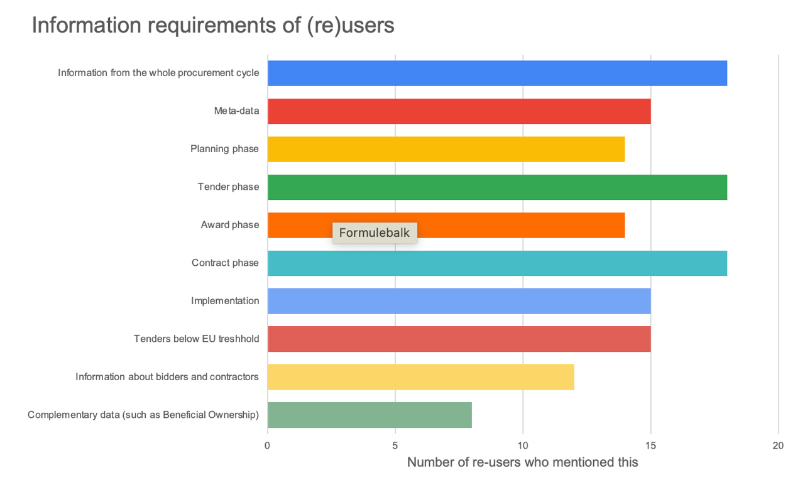

Information from the entire tendering cycle
According to users and re-users, the main idea is to publish different types of information from the entire public procurement process: from category plans to contract (renewals) and from payments to reporting from the implementation phase. It is precisely the complementarity and linking of these different forms of information that provides concrete added value for the diverse users and re-users. Below, the results of the interviews are categorised and explained for three specific procurement phases.

The planning and tendering phase
Procurement is not a goal in and of itself. The process should be designed to raise the level of performance and deliver valuable social outcomes, and not just in terms of compliance and completing forms. Additional data on the effectiveness of tenders and contracts is essential for users and re-users to have a role to play in this. Over the course of the interviews, several users and re-users stated that the effectiveness of, for example, social and sustainability objectives formulated in the category plans can only be examined and analysed if, within the tender and contract phases, reports are issued on how these have been applied. Several scientists and industry associations indicated that incorporating data fields into the announcement forms for tenders or linking data from the MVI self-evaluation tool to tenders and contracts offers added value. Doing so would allow for an indication of the extent to which external effects are taken into account and the extent to which policy objectives, such as sustainability, circularity, innovation, social aspects and focusing on smaller companies and start-ups, are being implemented. This information can subsequently be linked to contract and implementation, in order to examine how and to what extent the specific objectives have been achieved. Ultimately, contract managers will be able to indicate the extent to which the winning bidders fulfilled the promises they made.

Such information can also be used to record the effects on and of the tenders. A contracting authority may also reserve a contract for sheltered workshops and entrepreneurs whose main objective is to socially and professionally integrate disabled or disadvantaged people. At present, it is not possible to gain insight into the reserved contracts. Specifications of tenders on, for example, sites like TenderNed do not currently provide insight into which contracts are reserved for which type of organisations. Consequently, sheltered workshops often miss out on contracts. At the same time, publishing this data would enable accurate spending analyses and insight into which contracts are reserved for social enterprises.

‘Limited bidding’ tenders
Every year, two-thirds of all tenders in the Netherlands are organised on a single ‘limited bidding’ basis. This allows contracts for deliveries or services worth up to €50,000 and works up to €150,000 to be awarded by default on a one-to-one basis. Larger contracts for service, supply and works, up to the European threshold value, could also be put out to tender multiple times via limited bidding. The fact that these tenders and contracts are not made public is a thorn in the side of all users and re-users. Researchers, scientists and journalists stated that this prevents them from independently investigating the legality and integrity of these tenders, even though this is the type of tender most susceptible to favouritism and corruption. Entrepreneurs and suppliers are not able to apply for these types of contracts and tenders. Therefore, the priority in this category is to publish limited bidding tenders, with an emphasis on doing this as fully and publicly as possible.

Contracts and implementation
And not just the ‘limited bidding’ tenders: government contracts and the data they contain are also not public. The data currently published on Rijksoverheid.nl is minimal and anything but adequate for the needs of users and re-users. For users and re-users, public disclosure of government contracts remains their highest priority. Below, several data fields are briefly mentioned that can be used for this purpose.

Milestones and prices
Assessing whether a contract offers ‘value for money’ is essentially a question of understanding how well it is implemented (quality and compliance with specifications), if it is on time (achieving specified milestones) and if it offers a competitive price. Therefore, these data fields are also important for assessing this.

Reporting
The same is true of reporting. The efficiency and effectiveness of public tendering is not only determined by the bid price and achieving milestones. A clear view into the project plans, substantive reports and feasibility studies facilitates a greater understanding of how projects, services and works are realised. This data can be leveraged to enhance the efficiency of public tendering, to research what is and is not working, and it functions as a source for knowledge sharing.

Supplier data
Presently, only the company registration numbers of the main suppliers are published. However, this information is of limited use. The SBI codes, which reveal a company’s activities, can be used to sort tenders by industry on the supply side of the market. Supplier profiles can be generated from data like the names of owners, contractors or subcontractors, past performance and the number of tender applications. These profiles will be used to see how many current contracts the suppliers have (to determine whether they might be overloaded with too many active or overdue contracts), whether their past performance is on track or lagging and to see their past prices for similar goods or services. This type of profile also allows product or material suppliers to offer their products and materials to main contractors, as in the previous example regarding the development and furnishing of an office building.

Specific data needs
The usability of information, i.e. whether a certain meaning can be assigned and whether information can be effectively applied, is largely determined by which specific data/data fields are published. This section of the report examines the critical data/data fields that determine how useful the information is for public tendering. The needs of users and re-users are explained in the following overview.

All phases | 1. Planning
Tender identification number | Tendering logic
Name of the contracting authority | Planning in view of milestones
National identification number | Budget reserved for the tendering process
Address of the contracting authority | Project (name) to which the tender is linked.
Contact for the contracting authority | Justification of the reserved budget
 | Documents linked with the planning process
2. Tender | 3. Award
Tender ID | Number of tender applicants
Description of the tender | List with names of the tender applicants
Status of the tender | Award ID and description
Items to be tendered | Award decision and justification for award and exclusion
Socially responsible procurement | Motive and grounds for exclusion
Item classification | Award status
Estimated value of the tender | Award date
Tendering method | Award value
Justification for tendering method chosen | Names of suppliers
Which category the item belongs to | Supplier IDs: CoC, SBI, UBO
Award, exclusion and performance criteria | Address of the supplier
Method for submitting bids | Supplier contact information
Duration of the tender phase | Items awarded
Duration of the consultation phase | Classifications of the items allocated
Whether questions have been received | Contract period
Tender eligibility criteria | Relevant documents and annexes
Evaluation and award period | Contract start date
Estimated contract period | List with contract milestones
List with important milestones for the tendering phase | List with important milestones for implementation
Relevant documents and annexes
4. Contract and implementation | Corrections and amendments
Contract status | Corrections
Date and value of payment transactions | Justification for contract corrections and amendments
Payer and payee for payment transactions | Changes to the contract duration
Status of milestones for contract implementation | Adjustments of contract value
Documents and reports that are part of the implementation phase | Changes to the contract items or conditions

Publication requirements
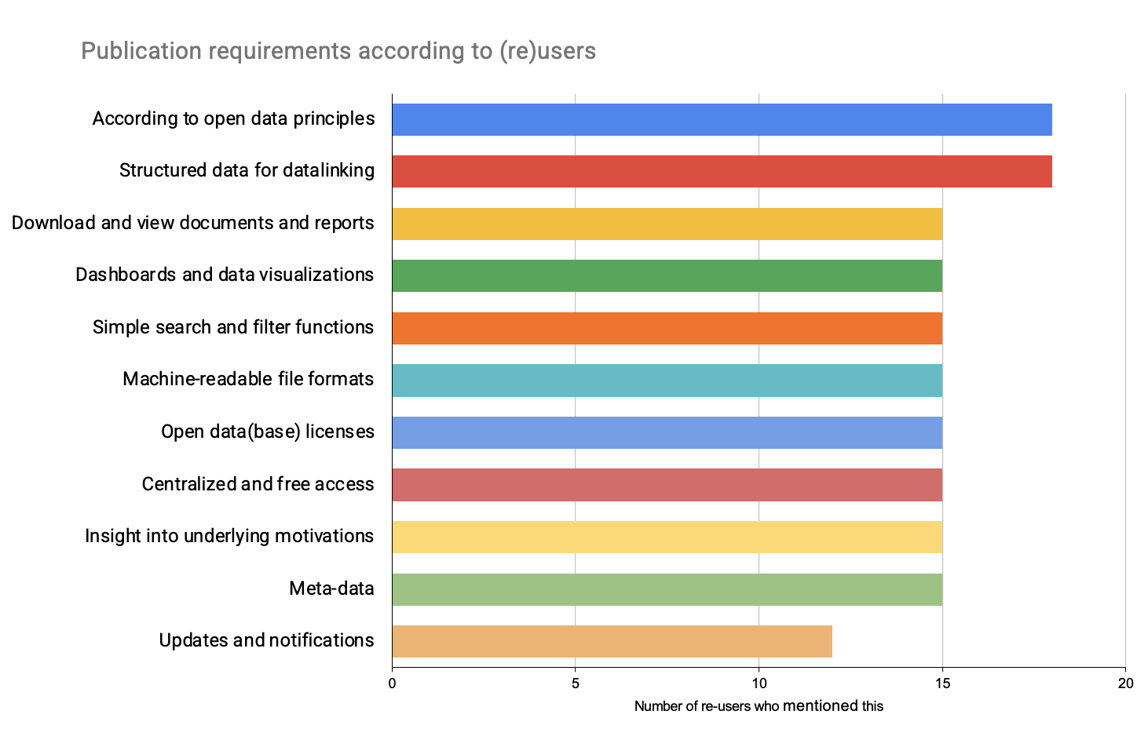
The way in which information and data are offered and/or published largely determines their usefulness. This part of the report describes the users and re-users’ wishes regarding public disclosure.

According to open data principles
Based on the interviews, the users and re-users need complete, up-to-date, machine-readable, freely accessible, licence-free, correctable data that comes directly from the data source. The following describes two of these elements: up-to-date disclosure and open data formats. These two requirements are in particular highlighted because up-to-date disclosure is a basic prerequisite and the format largely determines whether or not the information is usable.

Up-to-date disclosure
According to many users and re-users, up-to-date and real-time data publication is a fundamental requirement for public disclosure. The sooner the data is available, the more proactive the user cases. The majority of users and re-users indicated that timeliness is the main determining factor in how constructive their contributions are. For example, stakeholders can note if there are inconsistencies between the implementation schedule and actual progress on the project. If data like this is not available until the project’s completion, it is not possible to prevent or resolve implementation issues.

Open data formats
An announcement of a tender can contain many prices, and a contract can include many milestones. Using PDF format to publish this information allows for a document to be opened on any computer, tablet or smartphone, and it always looks the same. However, data in this file format are not very useful because the document does not have a good machine-readable structure. The same is true of tables and graphics. In the interviews, many users and re-users referenced JSON as the most obvious data format. An open procurement initiator from Poland indicated that this specific file format enables the publication of one-to-one relationships between the data elements within a tender process in a structured manner.

Structured data for datalinking
Linking data from the different procurement phases, such as which award criteria have been applied and how they have been applied for the supplier selection, is fundamental for the various users and re-users to efficiently use the procurement data. It is precisely by linking data from the entire supply chain and, among other things, by publishing metadata by default — such as which department is the portfolio holder — that users can become involved in various sectors in the improved understanding, analysis and organisation of public tenders. Researchers and procurement analysts recommended answering questions like ‘How competitive are the varied tendering methods across different products and governmental authorities?’, ‘How efficient are tenders in the different categories?’ and ‘What are the contributing factors for the price differences between specific goods and services?’

User friendly
Different types of re-use require different methods for publishing procurement data. For example, users and re-users are looking for bulk data published in machine-readable file formats that also support datalinking. Nevertheless, there is a need for a well-functioning API that facilitates the search for specific tenders, contracts and category plans through filter functions and keywords. Many users and re-users additionally indicated that fully operative search and filter functions, and dashboards that display information and data according to their preferences offer them added value.

Participation requirements
Collaborating with and organising proactive dialogue are essential for the successful deployment of public procurement data. This section of the report deals with users and re-users’ wishes and needs.

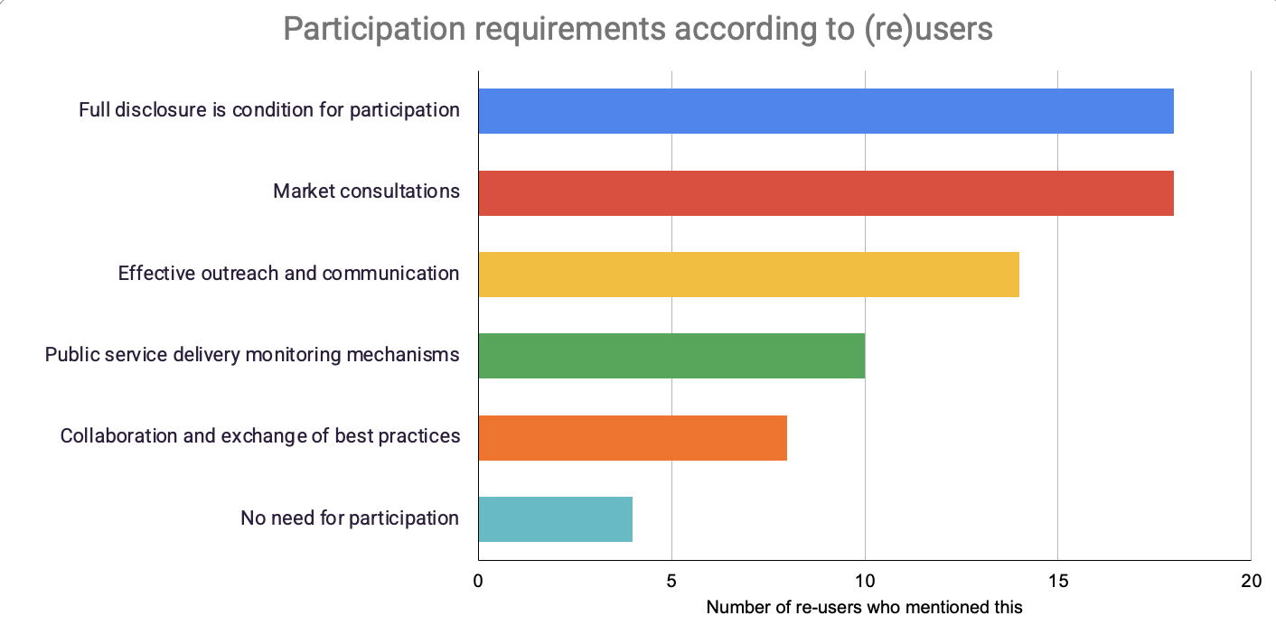

Complete information as a starting point
Based on many of the interviews, one prerequisite for effective participation is that all the data and information be published in full and in a timely fashion. Various users and re-users indicated that, in the absence of category plans, award criteria or contracts, it is impossible to hold a substantive, productive dialogue about what is going well and what remains to be improved. While there is a need for effective participation and dialogue, it also appears that the specific form and content depends on the objectives of users and re-users.

Public consultations
Industry associations, scientists and companies are calling for an online environment where they can be consulted and provide their input. These users and re-users are primarily looking for ways to participate in determining the procurement strategies, defining category plans and translating substantive objectives into concrete tenders. With (online) consultations that are open to the public, these users and re-users can, for example, help the contracting authorities organise and establish sustainable procurement. At a policy level, good ideas can be found within the government. However, in practice, it seems that translating these ideas into tenders could benefit from consultations. For example, aspects of sustainability are taken into account, but the weighting is too low, which means that there are limited opportunities for innovative entrepreneurs to offer their sustainable products.

Independent monitoring
Users and re-users who focus on monitoring the integrity and effectiveness of public tendering, specifically the contract and implementation phases, are looking for ways to participate other than private physical events and online market consultations. In order to supervise and control public tenders and, above all, to be able to signal when issues are being identified, these users and re-users need to be able to identify them. For instance, by allowing a ‘red flag’ to be placed on tenders for which relevant information is not published or for which unreasonably strict tender specifications have been applied. For example, diverse interviewees indicated that, if possible, anomalous bidding patterns or contract allocations could be directly investigated and addressed.

Recommendations
With users’ and re-users’ needs and wishes in mind, the final section of this report focuses on a set of recommendations for the development and implementation of an open platform for governmental procurement information.

Facilitate all forms of use and re-use
The first recommendation is to use the wishes and needs identified as the starting point when developing the platform. Do not be selective about which type of users and re-users to accommodate in their specific needs and wishes. These organisations all have a role to play in public tendering and they all contribute in their own unique way. Other countries that have organised open purchasing initiatives also show this to be the most effective: what can best be done with procurement data is also best thought up by someone else.

Publish data from the entire tender cycle
If the published data (the supply) does not match the user's needs (the demand), the data has less value and end users will be less quick to use and apply the data. There is a widespread need for diverse forms of information, ranging from category plans to contracts. Linking these different kinds of information will ensure that users and re-users are able to make constructive and critical contributions to the effectiveness and integrity of the public procurement process. Therefore, the second recommendation is to satisfy this widespread need of users and re-users.

Prioritise the publication of contract data
Users’ and re-users’ greatest need is to access the contract data that is currently locked up within assorted contract management systems. Without access to current and completed contracts, users and re-users cannot make constructive contributions. Redaction may be necessary in limited instances (e.g. national security, conspiracy or commercial secrets), but research has indicated that these cases are minimal.

Create a single source of truth
Currently, a significant amount public procurement data and information is already being published and stored within assorted online environments. Many of these platforms are not accessible for the users and re-users who wish to utilise this data. The fourth recommendation is for the platform to be the central location where all the information and data are provided. Use Common Ground principles to organise the information being provided. Uncoupling data from specific work processes and applications and retrieving data directly from the source (rather than repeatedly copying and storing them), will enable more effective monitoring of the data quality.

Open, unless
Presently, all users and re-users are experiencing issues with the completeness, correctness, usability and timeliness of the data available. Under the Open Government Act (Wet open overheid, Woo), which is to replace the Government Information (Public Access) Act (Wet openbaarheid van bestuur, Wob), the principle of active disclosure is enshrined in law for governmental authorities. Users and re-users are also calling for this. Apply the ‘open, unless’ principle here: make transparency the starting point. If certain dates and information are not published, explain the reason why.

Apply the Open Contracting Data Standard (OCDS)
Implementing the Open Contracting Data Standard (OCDS) is the most simple and secure way to publish tender data in a timely, centralised, freely accessible and user friendly manner. This data standard can be used to directly access and publish the relevant information from the planning, publication, award, contract and implementation phases. With this standard, procurement professionals and contract managers can ensure that data and documents are released and linked to specific phases and milestones. Users and re-users cannot participate constructively until this information is proactively shared. The OCDS also allows users and re-users to consult the data/data sets in bulk and via an API that provides various search and filter functions. This standard can be linked to tender and contract management forms that contain all the required data fields. Finally, the OCDS enables the linking of data from the different tender phases, which is a widespread desire among users and re-users. The Open Contracting Partnership, which manages the Open Contracting Data Standard, assists governmental authorities with the entire implementation process by providing step-by-step guidance as well as a resource library and a technical helpdesk. Globally, more than thirty governments use the Open Contracting Data Standard to publish their procurement data.

Develop mechanisms for consultation and independent monitoring
Public procurement reforms will not succeed without the participation and input of users and re-users outside the government. Different users and re-users have different wishes when it comes to which mechanisms are effective. Bearing in mind that complete information is a prerequisite for effective participation, this report recommends developing mechanisms for consultation and independent monitoring. Therefore, the open platform will be used for more than just transmitting data and information from the national government. It is precisely by developing specific mechanisms for users and re-users that contracting authorities can identify their most urgent needs and prioritize the publication of the appropriate and desired data and information.

Colophon

Publisher
Open State Foundation (OSF)
Marineterrein, Building 002A, Kattenburgerstraat 5, 1018 JB Amsterdam
www.openstate.eu

Author: Jesse Renema
Reviewers: Serv Wiemers, Tim Vos-Goedhart and Rosa Juffer.

Contact information
Tel. +31 (0)20 308 0567
E-mail: jesse@openstate.eu en contact@openstate.eu

Copyright Licence
Creative Commons BY 4.0

Significant (2016). The Dutch government’s purchase volume. Research commissioned by the Dutch government.
Follow the Money (2021). ‘Open House’ procurement formula is doping for youth welfare companies.
Follow the Money (2020). Unmasked: the fraudulent trade in face masks and ‘certificates’.
KPMG (2019). The impact of governmental procurement. A quick-scan report on the environmental and social impact of governmental procurement.
Open Contracting Partnership (2020). How governments spend: Opening up the value of global public procurement.
Knack, S. et al., (2019). Deterring Kickbacks and Encouraging Entry in Public Procurement Markets: Evidence from Firm Surveys in 90 Developing Countries. The World Bank Economic Review, 33, 287-309.
Open Government Partnership (2018). The Skeptic’s Guide to Open Government.
Open Government Partnership (2019). Open Contracting Factsheet.
Open Contracting Partnership (2021). Local Stakeholder Mapping: activity sheet. Part of the support provided by the OCP for implementing Open Contracting methods.
Ministry of Infrastructure and Water Management (2021) Tendering with ambition, procuring with impact
PricewaterhouseCoopers & Significant (2007). Procurement under European tender thresholds. Commissioned by the Dutch government.
National government (2021). Governmental contracts per 01 March 2021.
Open Contracting Partnership (2018). Mythbusting Confidentiality In Public Contracting.
More information about Common Ground is available at: https://bit.ly/3b1lqYQ
The national government’s policy on open data is available at: https://bit.ly/3nNF9Az
Open Contracting Governmentship (2021). The Open Contracting Data Standard.

